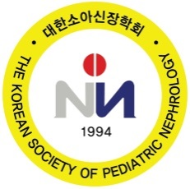

Invitation Letter

Name:

Affiliation:

Abstract Title:

Welcome to The 22nd Korea-China-Japan Pediatric Nephrology Seminar 2026
on April 25 at Jeju Shinhwa World Hotel & Resort, Jeju, Korea. As the hosting president, it is our great pleasure to have you as a speaker in the 22nd Korea-China-Japan Pediatric Nephrology Seminar 2026.

Our most important meeting goals have always been to share knowledge among us and to promote our meetings. I hope you enjoy yourself and find the meeting informative and valuable. You may have the opportunity to meet and chat with members of the community through our upcoming meeting.

Your presence will definitely make the meeting more joyful and memorable.

Sincerely,

Joo Hoon Lee, M.D., Ph.D.
President
The Korean Society of Pediatric Nephrology

