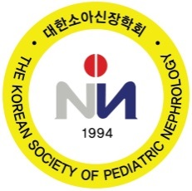

Invitation Letter

Name:

Affiliation:

Abstract Title:

Welcome to the 16th Korea-China-Japan Pediatric Nephrology Seminar 2018 and the 2018 Spring Conference of the the Korean Society of Pediatric Nephrology on April 14 at Shilla Stay Haeundae, Busan, Korea. As the hosting president, it is our great pleasure to have you as a speaker in the 16th Korea-China-Japan Pediatric Nephrology Seminar 2018.

Our most important meeting goals have always been to share knowledge among us and to promote our meetings. I hope you enjoy yourself and find the meeting informative and valuable. You may have the opportunity to meet and chat with members of the community through our upcoming meeting.

Your presence will definitely make the meeting more joyful and memorable.

Sincerely,

Kee-Hwan Yoo, M.D., Ph.D.

President
The Korean Society of Pediatric Nephrology

